



August January
17th/18th Meet the Teacher 1st-4th No School- Christmas Break


19th First day of school 18th No School-MLK Day
24th/25th Welcome coffee February

26th Car line begins 1st -Registration due for current students
September 3rd Registration opens to the Public

7th No School-Labor Day 11th/12th Valentine’s Day parties

14th Community Night- 15th No School- President’s Day
Dillard’s Ice Cream 19th Donuts for Grown Ups

14th/15th Fall Pictures March

16th Make up pictures 1st Community Night-
This Photo by Unknown Author is licensed under CC BY-SA
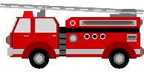
October Chick-Fil-A
5th Fire Truck 10:00 1st-5th Spirit Week
5th Community Night- 12th No School

The Clock (weather make up day-if needed)
16th No School 22nd-29th No School- Spring Break
29th/30th Halloween Parties April

30th Fall Festival (5-7pm) 3rd Super Saturday
November 4th-9th Teacher Appreciation Week


2nd/3rd No School-Election Day 16th No School
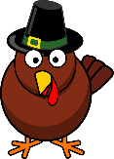
11th-13th Scholastic Book Fair 21st-23rd Art Show
23rd Thanksgiving Feast May

25th-27th Thanksgiving Break (No School) 13th-19th Silent Auction

December 17th Graduation 6:30pm
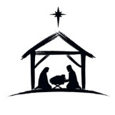
5th Super Saturday 19th Picnic 12:00

15th/16th Christmas parties 21th End of year Program 9:30am
17th Christmas Program 9:30am SGPS
18th-31st No School-Christmas Break

